UML

Class diagram

Functional style of programming

Lisp Scheme SML

1) TM Regularly

2) Bed Early

3) Focus

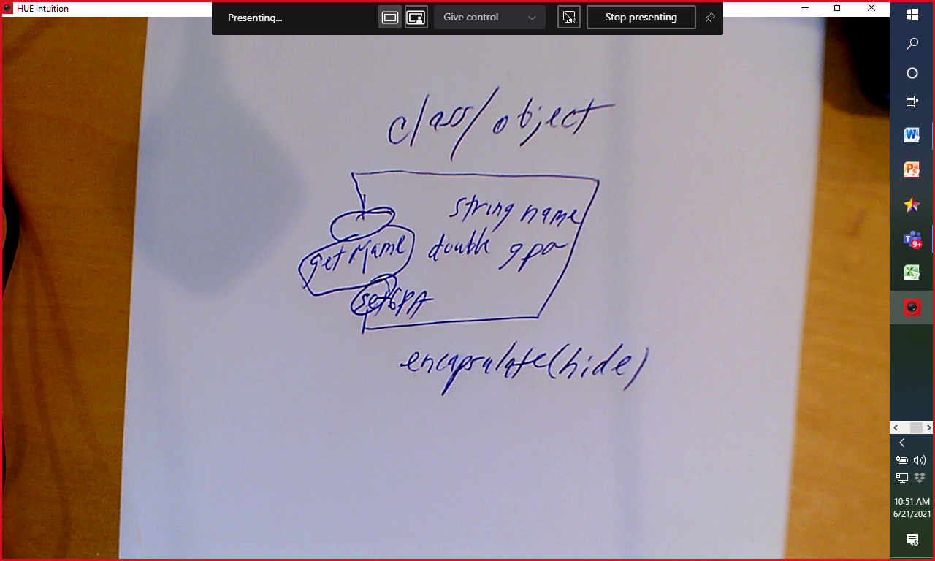

Analysis What

Design How

Implementation code

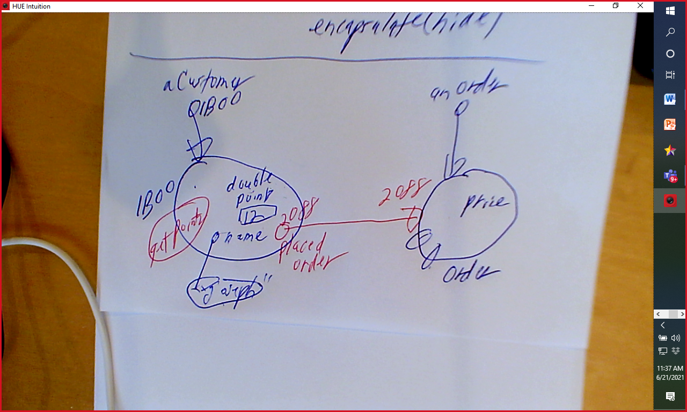

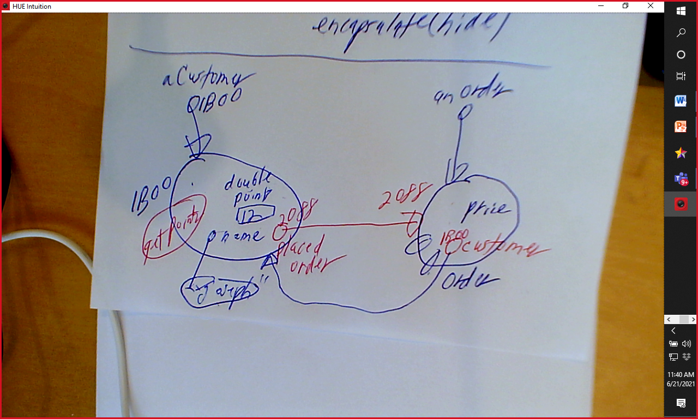

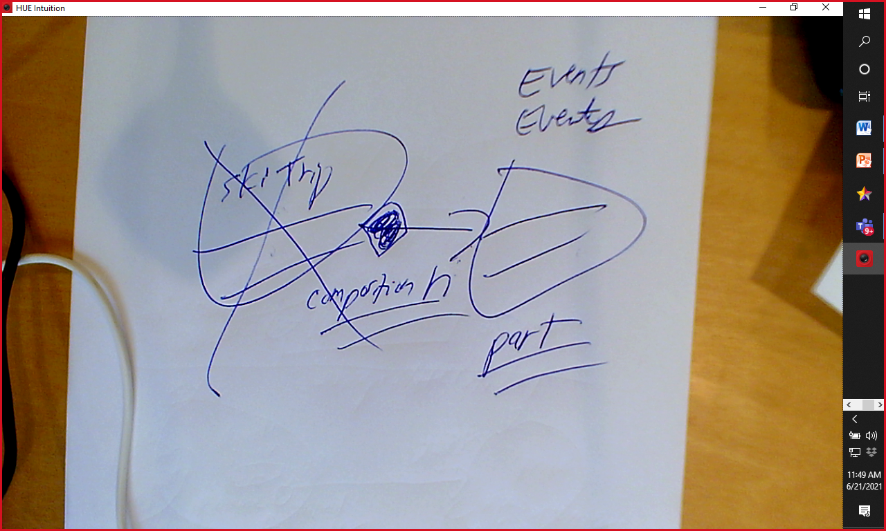

(0 + 3\*3) + 10 \* 10) + 6 \* 6)